Website improvement recommendations

Form
- Asterisk should have some more vivid color which can indicate to users that it is not just a text but rather some sign.
- Would use :focus-visible instead of simple focus, if someone wants to navigate the website via keyboard, or if keep using only :focus change the border color to more vivid color to have a clearer vision which is the currently selected field.
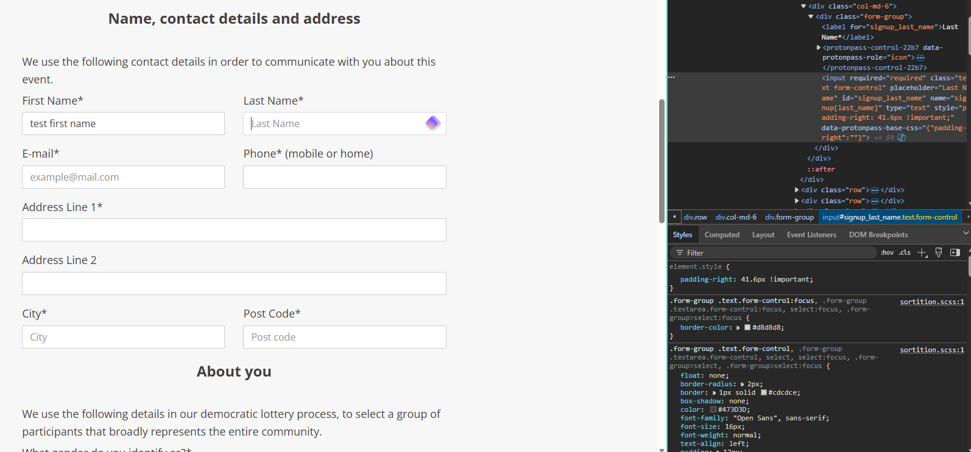
  - In some cases, keyboard navigation was not clear, which element was in focus, for instance:

In this example the element has focus on it but with a very light color and it doesn’t have that great contrast between the default element and the currently focusing element.

- Would add role=”alert” to the required input field’s label and use a for to connect the label to the input field to make it easier to understand user who use screen readers what they missed to fill out.
- I would move the content of the form into 4 fieldsets to have a clear distribution of the elements and this can also help users using screen reader to have a better understanding of what is the next required information they must provide. Such as at first it was contact information and in the next section it is about personal informations.

- Use aria-descibedby=”” and connect it to the error messages for easier understanding for screen reader users.
- Would add autocomplete attribute to the form just to ease the form filling for the users. Users may have information which they used somewhere else before which can improve user experience if they don’t have to type everything again.
- The register button should have a better contrast color on :hover and also on :focus or :focus-visible.
- Custom error messages can help the user where and what to fix in order to successfully submit the form. Understandable response messages are crucial to have a fluid user-experience. And at the beginning turning off the default client-side validation with novalidate. Add a custom client-side validation just to have both client and server side validations as well.

ChatGPT/Claude conversations

